Machine Learning Project BLOG
Topic : HR Analytics
Today I am going to write about a complete project for HR Analytics which should serve as a guiding path for many Data Science aspirants. When I began my journey into studying Data Science, I was overwhelmed by the content that is available online and most of it scattered into chunks emphasizing on a deeper knowledge that a newbie will most likely not be able to comprehend or connect through. I agree that there are already many projects available on some deep web beneath multiple clicks and paths hidden like a core of an onion protected by multiple layers. But here I am just trying to do my bit in making things easier for a newcomer to understand the basic architecture that’s required in the real world for creating a Data Science project.

So, without any further ado please allow me to explain the agenda for this blog post. In this article, I have jotted down all the techniques in the form of sub-topics that I will be explaining one by one. And those pointers are as follows:
1. Problem Definition
2. Data Analysis
3. EDA
4. Pre-processing Data
5. Building Machine Learning Models
6. Concluding Remarks
Let’s start with the problem definition or a short introduction on the project that I have chosen to elaborate and why it was made in the first place.

1. Problem Definition
The project I am using for this article is for HR Analytics which is basically a fictional dataset that was created by the Data Scientists at IBM. You can find the dataset here on the Kaggle website. Basically, every year a lot of companies hire a number of employees. The companies invest time and money in training those employees, not just this but there are training programs within the companies for their existing employees as well. The aim of these programs is to increase the effectiveness of their employees. But where does HR Analytics fit in this? and is it just about improving the performance of employees?
Human Resource Analytics (HR Analytics) is an area in the field of analytics that refers to applying analytic processes to the human resource department of an organization in the hope of improving employee performance and therefore getting a better return on investment.

Attrition in human resources refers to the gradual loss of employees’ overtime. In general, relatively high attrition is problematic for any company. HR professionals often assume a leadership role in designing company compensation programs, work culture and motivation systems that help the organization retain top employees. How does attrition affect companies and how does HR Analytics help in analysing attrition? We will discuss the first question here and for the second question, we will write the code and try to understand the process step by step.
Attrition affecting companies is a major problem since high employee attrition is its cost to an organization. Job postings, hiring processes, paperwork and new hire training are some of the common expenses of losing employees and replacing them. Additionally, regular employee turnover prohibits an organization from increasing its collective knowledge base and experience over time. This is especially concerning if your business is customer-facing, as customers often prefer to interact with familiar people. Errors and issues are more likely if you constantly have new workers too.
Therefore the major goal of this project is to identify the “Attrition” rate as a simple Yes or a No tag making this to be a classification problem!
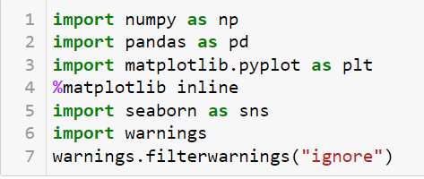
First we are going to import all the necessary dependencies here that will be used in our project and obtain the rest as and when required. Before we begin with any process, we need to get the dataset in our Jupyter Notebook that can be achieved by a single step.
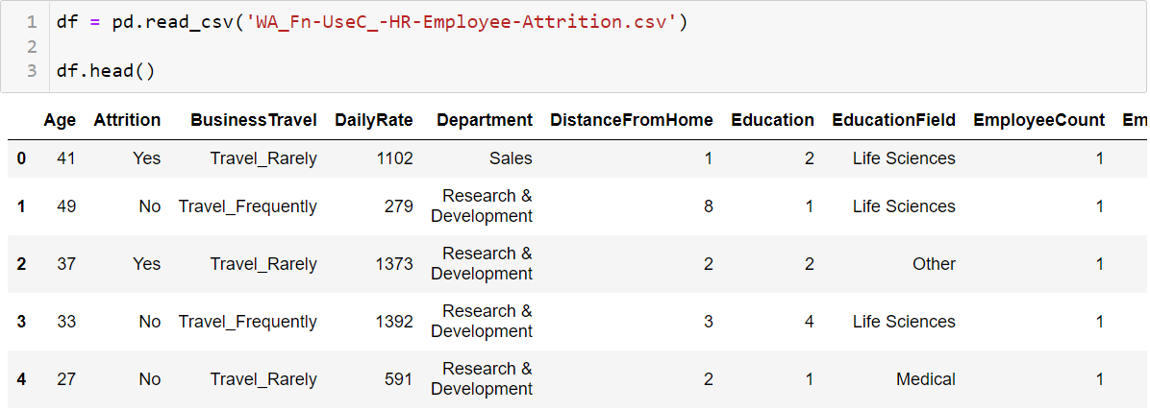
This gives us our entire dataset stored in the variable name “df” for our dataframe.
2. Data Analysis
For the data analysis part we can simply eyeball the contents for our dataset trying to make sense of some columns, its related values and anything that comes to your mind.
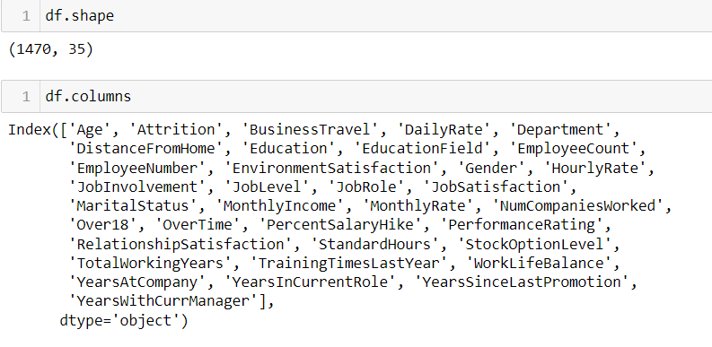
In the above line of code we can see that the total number of rows present in our data is 1470 and the total number of columns are 35. Since it is a dataset with a reasonably higher number of rows and columns the visualization gets truncated.
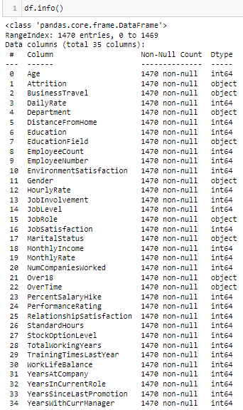
I also provided information about the dataset which gives a brief distribution about our data.
3. EDA
EDA also known as Exploratory Data Analysis is considered the most important aspect in Data Science by many Data Scientists including me. After following a huge number of expert Data Scientist on various platforms I can confirm one thing that it boils down to a single important thing of conveying a story on how you were able to achieve each and every step via your code showing the provided problem statement, the observation, the challenges faced and what was done to tackle or rectify those issues.
Building a good model comes only when you understand clearly what you are doing and why you are doing it. Making sure that you have clean data in the proper processed format to feed into your model and get appropriate results. Because no amount of Machine Learning model usage and hyper parameter tuning is going to help if you have not invested time to sort out and fix your data, that's the only input you have at hand.
There is this famous saying amongst Data Scientist and also people who work with data that goes something like “Garbage in Garbage out” simply translating to mean, if you are trying to build an automated model or make sense out of data that you have you need to clean it and work on it thoroughly before you even start utilizing it further. I cannot stress enough on the process of clean data collection more than anything but in the real world there is no such thing as clean data. That’s where data analysis comes into picture and using multiple methods from data cleaning to data pre-processing and then data engineering brings us closer to get our desired label prediction.
Enough of the story telling let me show you the code since talk is cheap, but also necessary at times to explain what really is going on. The first thing I am going to take a look at is the missing data information in our dataset by using the codes below.
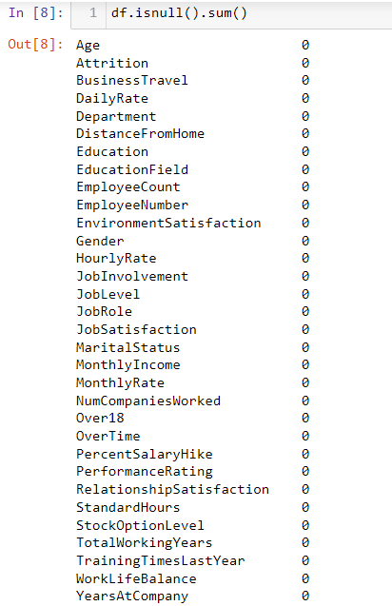
Now that we were able to confirm our dataset being free of any missing data we will drop any duplicates that might be present using the code below.
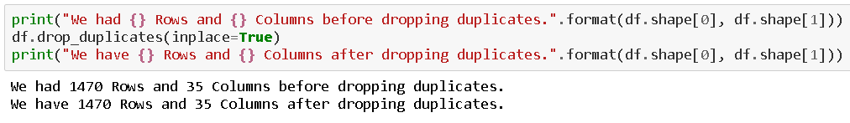
With the `drop_duplicates` option I was trying to get rid of all the duplicate data present in our dataset. However, we can see that there are no duplicate data existing in our dataset. Next, we move on to using the describe method to take a look at the count value, mean data, standard deviation information and the minimum, maximum, 25% quartile, 50% quartile and 75% quartile details. As the describe method works best for numeric data all the object (text) type data gets ignored. Take a look at the below code and you will get an idea on how to use it.
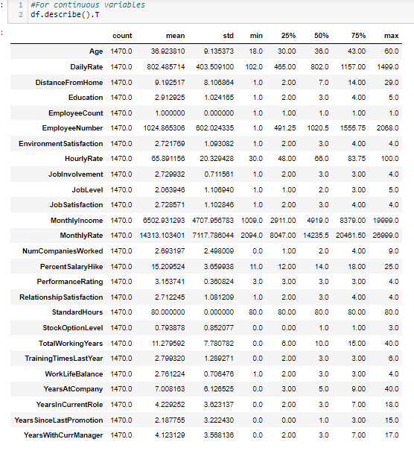
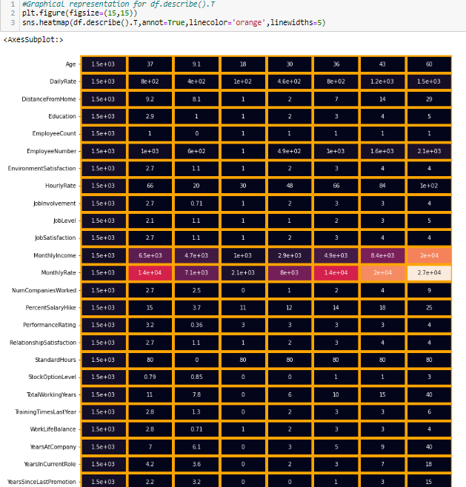
Once you have used the code the output provided is in transpose format to accommodate all the columns from our dataset in tabular as well as visual format.
When we are able to draw insights from the describe method we can take a look at the datatype information using the code below and that shall give us the list of all the columns marking them to be either integer, float or object datatype depending on the values present inside the columns.
Conclusion from the 1st part:
1)Imported the required libraries.
2)Load the data set.
3)Use different pandas methods to know about the dataset.
4)Checked for any missing values
5)Show the data summary.

UNIVARIATE ANALYSIS
Univariate analysis is the simplest form of analyzing data. Uni means one, so in other words the data has only one variable. Univariate data requires analyzing each variable separately. Data is gathered for the purpose of answering a question, or more specifically, a research question.
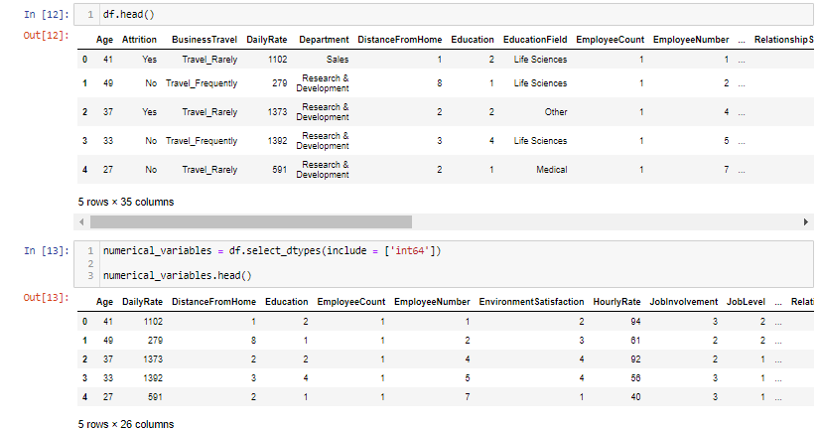
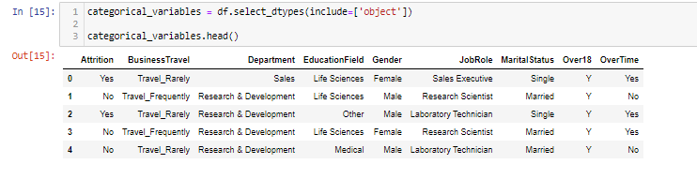

This allows us to store the column names in a list format within the variables namely object_datatype and integer_datatype.
After I have bifurcated the datatype column names in two separate lists, we will take a look at the overall unique values for all the columns and then the data numbers for only object data type columns using the below codes.
These lines of codes provide us the output where we get an entire list of column names with unique data covered in the dataset rows providing numerical data and then a description of those values for categorical object data type columns.
Considering the separation of object data I then take a visual on how many rows or count of rows these values cover in our data set. Usage of various visualization techniques allows me to optimize and analyse the columns further. It gives me an idea as to where data pre processing will be needed and where removal of those data will benefit. Honestly all this can only be acquired from practising on different projects and as everyone says the more you work the more you acquire knowledge in that field working like a 6th sense in such project creation. I am giving this example here but it does not mean that these are the only steps when it comes to creating a project. The architecture or the backbone of the project will remain the same however depending on what data you are working on the usage of techniques will all differ.
For example in this project I did not get any missing value therefore I did not worry about handling them but there are datasets which have a lot of missing data which are then filled using various methods and are at times even discarded as a last resort if it is only going to make our machine learning model biased towards one data value or category.
Let me go ahead and list down all the visualization codes and their output for your reference.
Code:
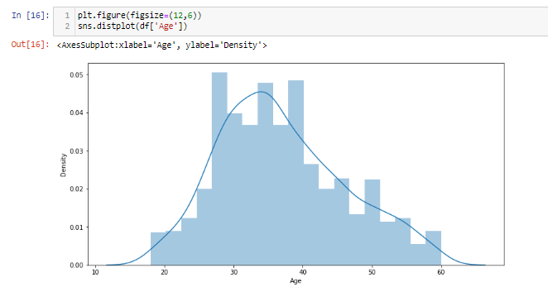
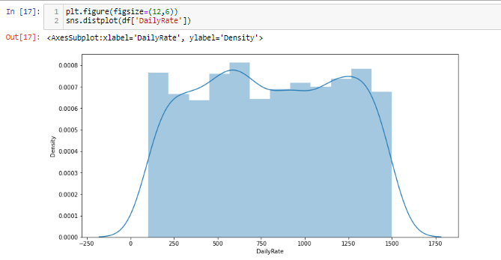
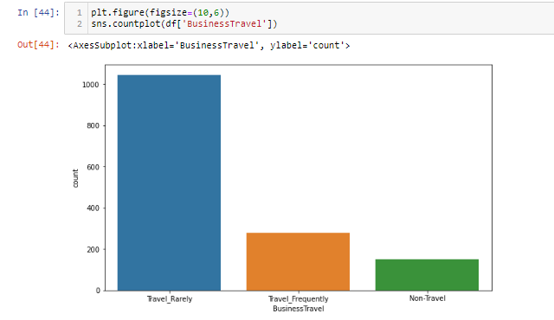

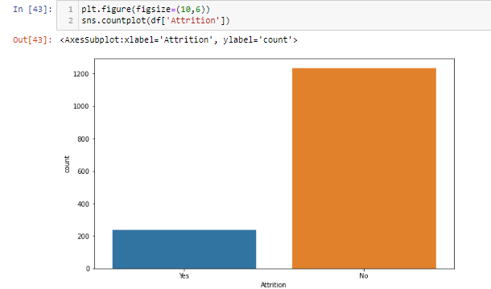
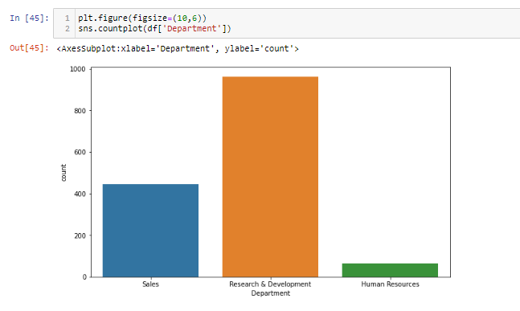
I have not taken every feature and plotted down here.I have done univariate analysis on numerical and categorical variables.Now I will be proceeding to bivariate analysis.

BIVARIATE ANALYSIS
Bivariate analysis is stated to be an analysis of any concurrent relation between two variables or attributes. This study explores the relationship of two variables as well as the depth of this relationship to figure out if there are any discrepancies between two variables and any causes of this difference.
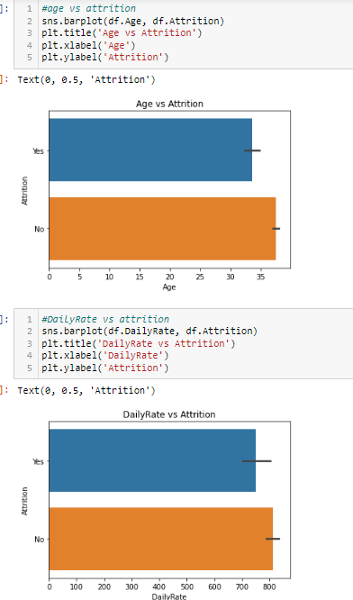
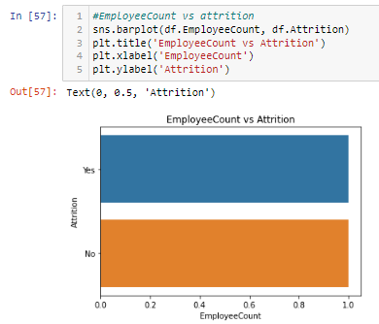
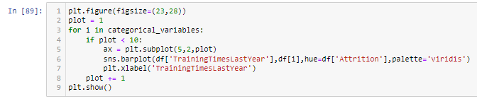
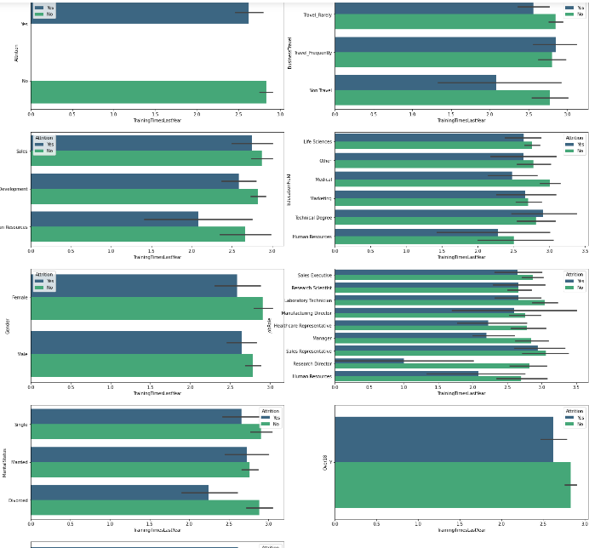

We have not taken all the numerical variables into consideration,we just took 8-9 features to just give a brief look upon how the distribution pans out.The distribution was between numerical variables with categorical variables with hue being the target variable i.e Attrition.You can see that with the help of above codes and getting the outputs I was able to take a look at all the column values/counts, the boxen plots gave me a view on the presence of outliers and the distribution plots showed me the skewness information that needed to be treated. These are like the challenges that will need to be dealt with before I even think of building my Classification Machine Learning models.
4. Pre-processing Data
In the pre-processing step I am going to tackle all the misfits and fix them one by one starting with the problem that our dataset has object data type values whereas our Machine Learning models can only understand numeric values. I am making use of the encoding methods to convert all the object data type values. For our label I am using Label Encoder while for other categorical feature columns I am using the Ordinal Encoder. Instead of the Ordinal Encoder I could have used The One Hot Encoder but as I mentioned it is all about preference with trial and errors. The One Hot Encoder method increases the number columns while application of Ordinal Encoder on data values offering an order deems a better option to me. I have also seen many people apply Label Encoder on feature columns as well and it does not make any sense to me since the name itself says Labelencoder how much of a specification is required to understand that it is only for our label(s) columns. Hope my readers won’t make the same mistake!
Code:
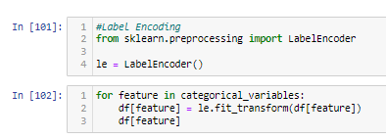
Output:
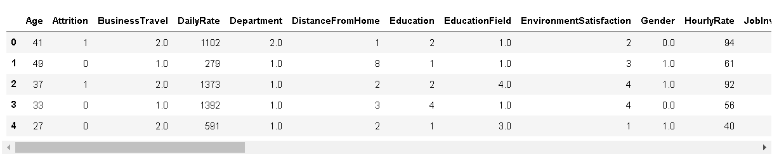
After I have encoded all the columns in our dataset, I am using a Histogram to view the data distribution. Since Histograms only consider numeric data it should be able to identify all the information from our encoded dataframe.
Code:
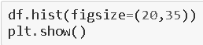
Output:
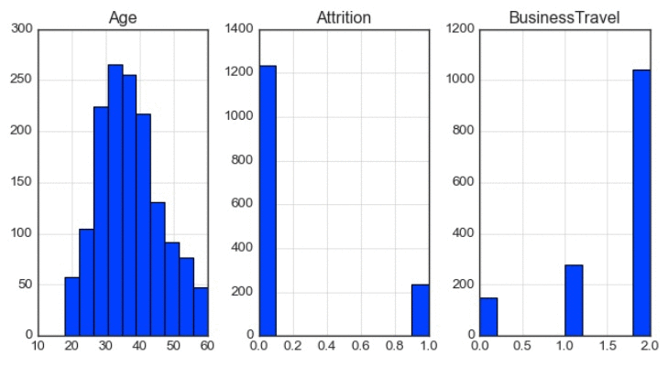
I now feel the need to check for correlation details in our dataset through a Heatmap. For those who still feel a confusion on correlation details let me break it down in two simple points that there are Positive correlation - A correlation of +1 indicates a perfect positive correlation, meaning that both variables move in the same direction together and Negative correlation - A correlation of –1 indicates a perfect negative correlation, meaning that as one variable goes up, the other goes down. The code to see this information is displayed below.
Code:
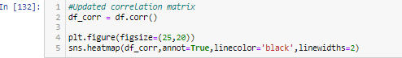
Output:
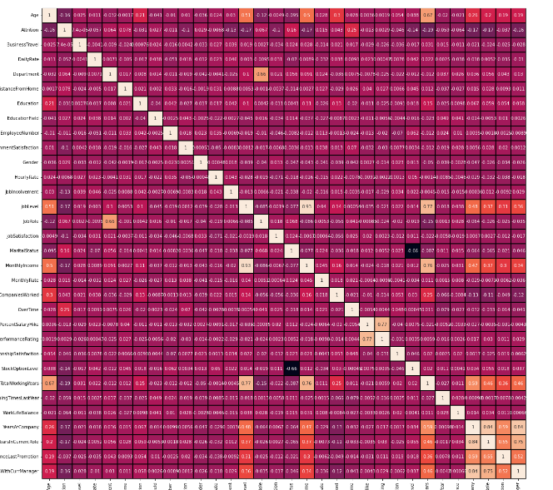
Trust me even on the Jupyter Notebook it looks all tiny due to the high number of columns. So, in such scenarios I majorly look at the colours to understand if there is any multicollinearity issue among the feature columns and if there is still any column that I can drop. But to clearly view the correlation between our label and feature columns I use a Bar Plot comparison and you can find it’s code here.
Code:
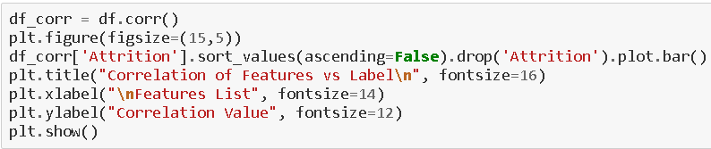
Output:
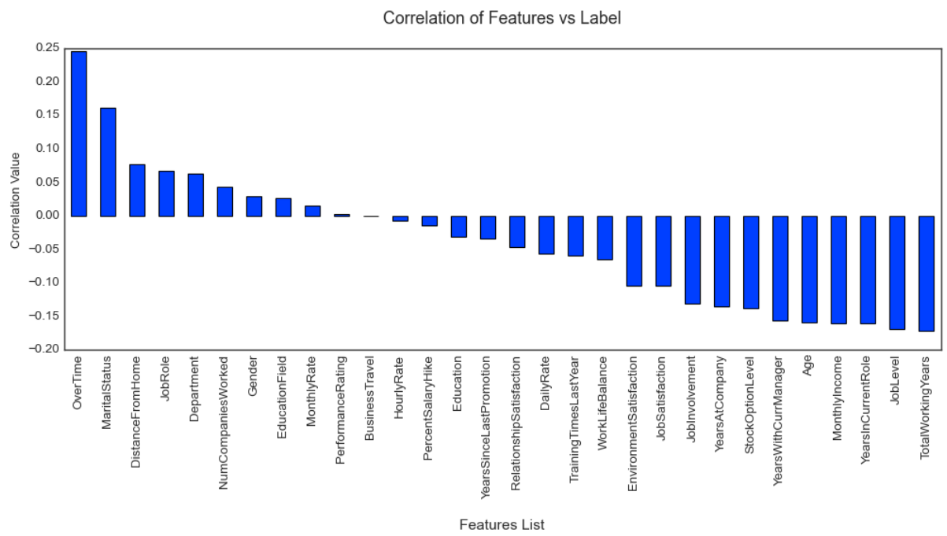
In the above Bar Plot we are able to clearly define the feature columns that are positively correlated with our label and the feature columns that are negatively correlated with our label. Now coming back to the outlier and skewness concern in our dataset I will be using the Z score and Log transformation methods.
Code:
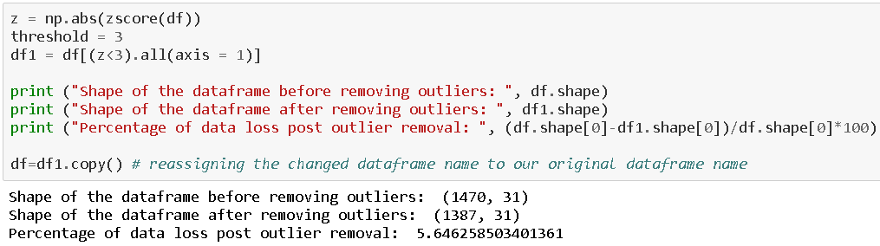
As for the usage of Z score, I was able to lose only about 5% of data but when I used the IQR method it took away I believe 30% of the data. And as Data Scientist retaining valuable data always takes priority and fixing it rather than simply deleting it unless it is the last resort. After this I am using the Log transformation to deal with the skewness since the acceptable range lies between +/-0.5 value for each column.
Code:
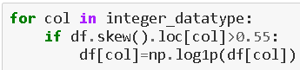
After dealing with the data concerns I will then split our columns into feature and label. I am storing the feature columns in X and the target label column in the Y variable.
Code:
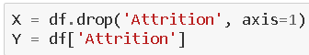
But there was an imbalance between the label classes. If you would notice the value displayed in the count plot earlier, there was a huge difference between the “Yes” and “No” data. Therefore, I will have to resolve it as the imbalance can make our machine learning model biased towards the “No” value.
Code:
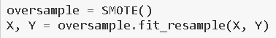
Then I will also scale the feature columns that are stored in the X variable to avoid any kind of biases over column values. Some integers cover thousands of places and some cover hundreds or tens of places then it can make the machine learning model assume the column with thousands place has a higher importance when in reality that won’t be true due to difference in unit range.
Code:
I would like to share a simple piece of code that allows us to choose a fitting random state for the machine learning models.
Code:
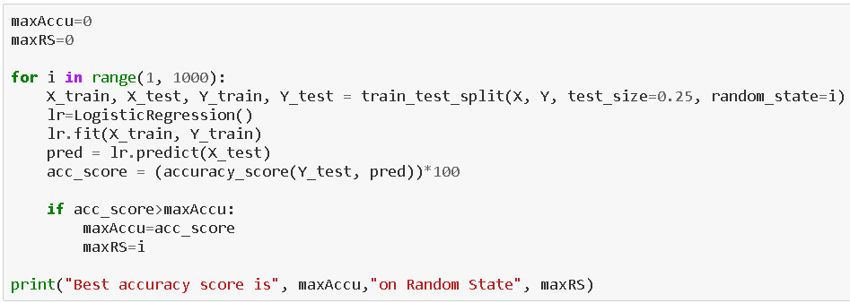
Then I will use the train test split to bifurcate our entire data set into training data and testing data. Here I am using 75% data for training purposes and 25% data for testing purposes. Some people provide training and test data separately as well and hence it completely depends on you how you want to use this step.
Code:
Now at this critical step before building my machine learning model I take a look at the importance of my feature columns. This gives me an insight on how the feature columns are involved and what kind of weightage they have in predicting my target label.
Code:
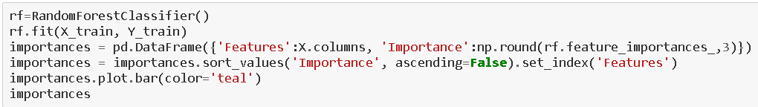
Output:
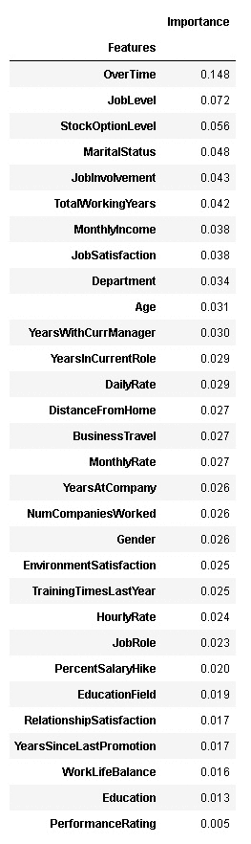
Once we have invested enough time in doing EDA and Pre-processing our data comes the step for which all the previous hard work was performed. That is to finally start building our Machine Learning model for classification purposes.
5. Building Machine Learning Models
In order to build a classification method I have imported the necessary libraries and created a function that contains all our machine learning model creation and its evaluation metrics steps. This makes our job easier since later on we just need to feed the model’s name and get the result without repeating/rewriting the same code again and again.
Code:
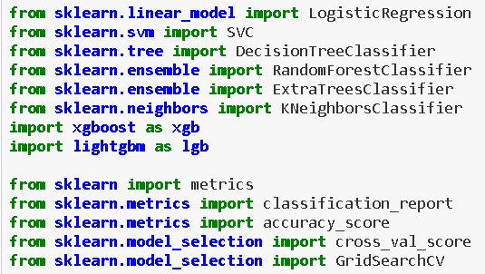
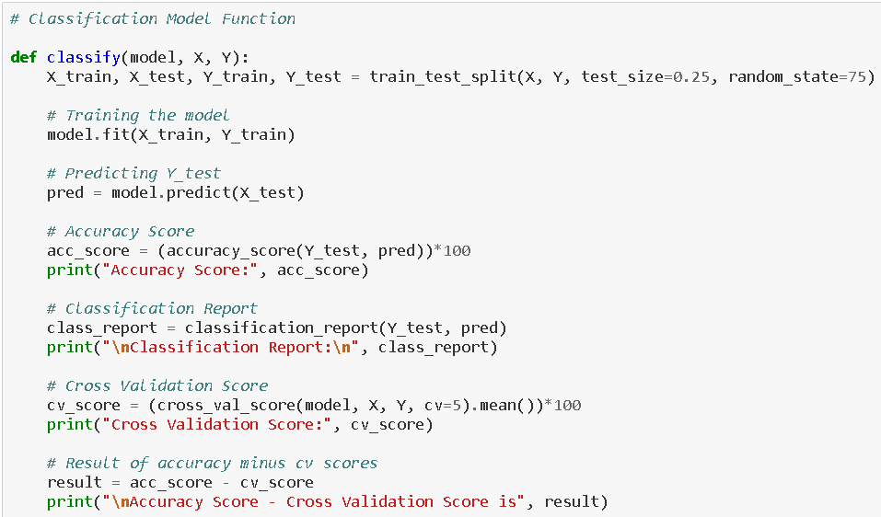
Output:
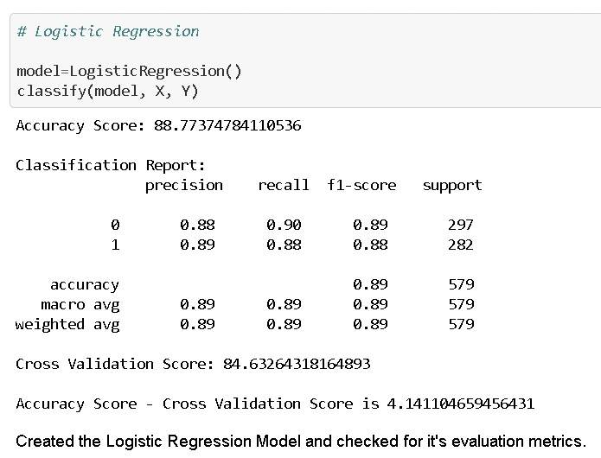
It is always advisable to build more than 5 machine learning models so that you can choose from the best performing model and then apply hyper parameter tuning to make it perform even better. I am going to use the Random Forest Trees Classifier as my choice of classification model as I see it is doing better than the other models I used.
Code:
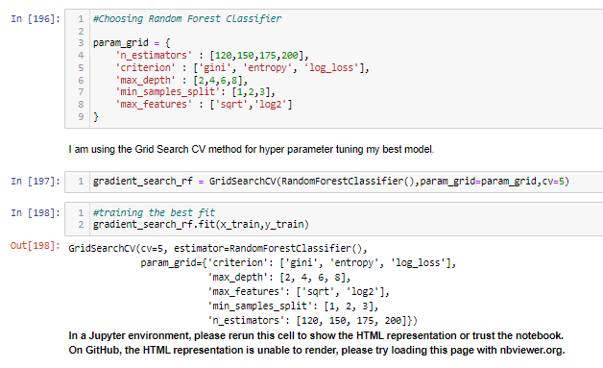
After applying the above steps to get the best parameters list, I simply have to plug it into my final model and receive the output of it. I have created an ROC curve plot and Confusion matrix for the final model.
Code:
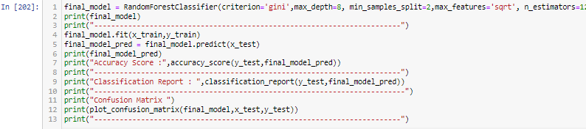
Code: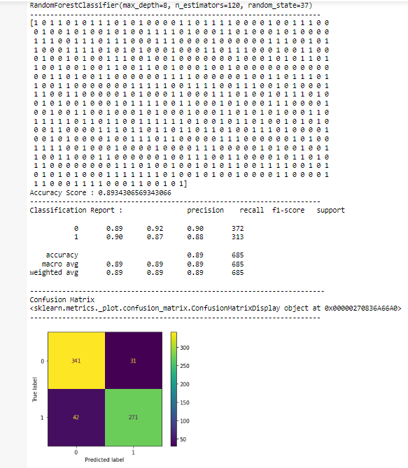
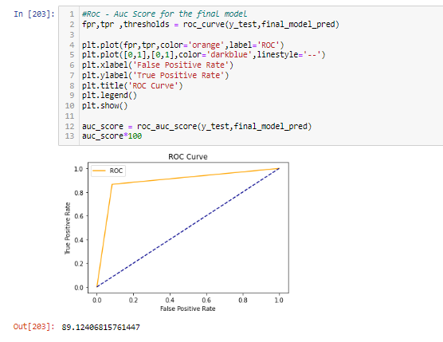
Accidentally I forgot to edit the print statement for my confusion matrix and it still shows the earlier Decision Tree model name instead of the Random FOREST Trees model name and has the values stored for the latter. This also proves that your best performing model can keep changing at times even without changing your code and simply running it multiple times. But I am sure you can understand that the print statement can be changed as per your liking and the important stuff was on the utilization of the code showing the correct result.
Once you have gone through all the previous steps and you are satisfied with the outcome you can then save the final model using either joblib or pickle. I have used the joblib method to save and then load my model from the same saved filename.
Code:
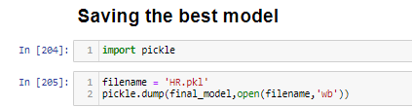
6. Concluding Remarks
Kindly allow me to provide a quick recap on all the steps that we went through starting from understanding the Problem Definition then going through the Data Analysis and EDA processes. We went through the necessary Pre-processing Data steps before the final Building Machine Learning Models step came into picture.
What I do is code my entire project on my own and then take a peek at the internet to look through other’s coding style for inspiration and understand if I can incorporate anything to improvise further on accuracy or beautify the visuals. However, I have seen many people doing the complete opposite whereupon they don’t practise or create their own unique coding style first and rather copy paste lines from the web and perform some sort of messy patch work and when asked to explain might not be capable of conveying functioning or usage of those code blocks.
Before wrapping up my only advice to everyone is “No pain No gain” you will have to get your hands dirty with building your own code and trying out all the permutations and combinations. Create a self-made unique data storytelling commandment list and follow it along with the standard project life cycle. Hope this at length article helps you in gaining the initial knowledge on building your first project from scratch.

